
EMPLOYMENT APPLICATION REVIEW SYSTEM (EARS)
D4 · Detailed Design
Software Engineering — COSC 3506
Version 1.0 — Approved
Prepared by Chisom Ugochukwu & Yinka Akingbaso
Algoma University — July 29, 2026

Contents

1. UML Class Diagram 3
2. Sequence Diagram: Application Submission 4
3. Activity Diagram: Application Review Workflow 5
4. State Diagram: Application Lifecycle 6
5. Data Flow Diagram (Level 1) 7

1. UML Class Diagram
The system is modelled as five cooperating classes (Figure 1). Each class encapsulates its own state and behavior, and relationships are expressed with explicit multiplicities.
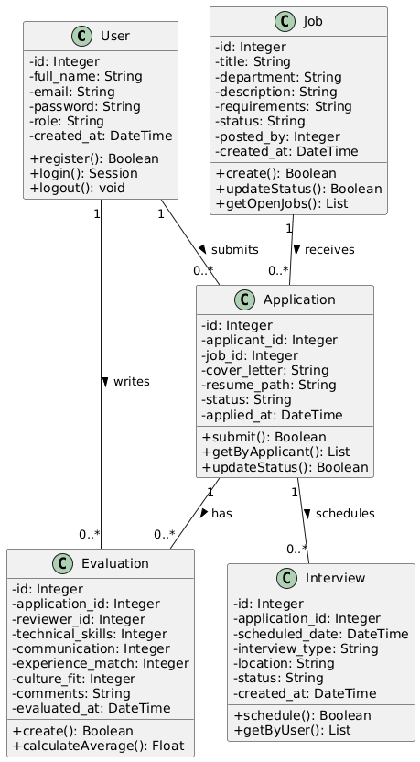
Figure 1: UML class diagram — entities, attributes, methods, and relationships
Class | Responsibility | Key Methods
User | Identity, credentials (hashed), and role (applicant, reviewer, admin) | register(), login(), logout()
Job | Job postings with lifecycle status (open, closed) | create(), updateStatus(), getOpenJobs()
Application | Cover letter, resume, and status for one applicant–job pairing | submit(), getByApplicant(), updateStatus()
Evaluation | Four criterion scores (1–5) plus comments for an application | create(), calculateAverage(), getByApplication()
Interview | Scheduled date, type, location, and status for an application | schedule(), getByUser()
Relationship | Multiplicity
User submits Application | 1 to 0..*
Job receives Application | 1 to 0..*
User writes Evaluation | 1 to 0..*
Application has Evaluation | 1 to 0..*
Application schedules Interview | 1 to 0..*

2. Sequence Diagram: Application Submission
Figure 2 traces the submission of an application across the browser, authentication middleware, application controller, and database — including the duplicate-application exception path.
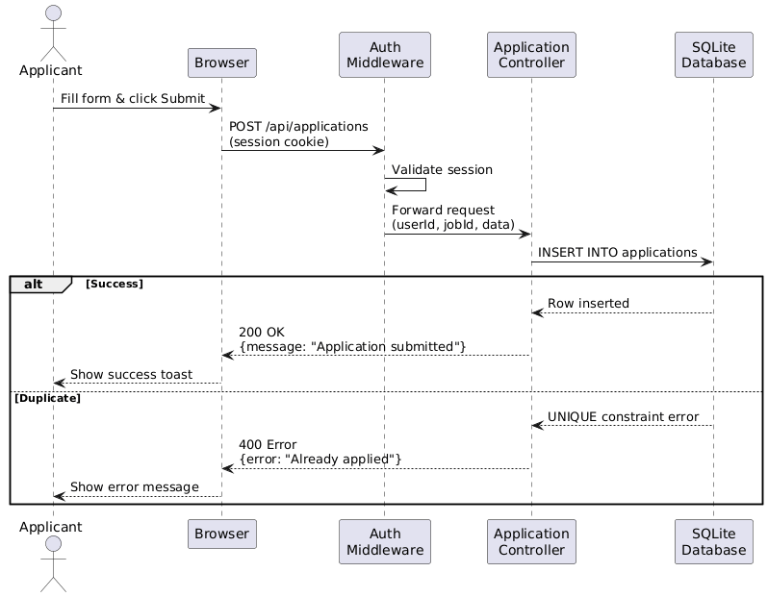
Figure 2: Sequence diagram — application submission with success and duplicate branches
Step | Interaction | Message
1 | Applicant → Browser | Fill the application form and click Submit
2 | Browser → Auth Middleware | POST /api/applications (with session cookie)
3 | Auth Middleware → Controller | Validate session; extract userId
4 | Controller → Database | INSERT INTO applications (applicant_id, job_id, cover_letter, resume_path)
5 | Database → Controller | Return success, or UNIQUE constraint error on duplicate
6 | Controller → Browser | JSON {message: "Application submitted"} or {error: "Already applied"}
7 | Browser → Applicant | Display success toast or error message

3. Activity Diagram: Application Review Workflow
The reviewer workflow is a sequence of decisions, each with a defined system response:
- The reviewer logs in and opens the applications dashboard.
- The reviewer selects an application and decides whether to evaluate the candidate.
- If yes: open the evaluation form, enter the four scores (1–5 each), and the system calculates the average and saves the evaluation.
- The reviewer then decides whether to update the application status; if yes, they select the new status and save.
- At any decision point the reviewer may schedule an interview by entering the date, type, and location; the system saves the interview and notifies the applicant.
- Each branch terminates cleanly — no workflow path leaves the application in an undefined state.

4. State Diagram: Application Lifecycle
An application moves through five states. Every transition is triggered by an explicit reviewer action, and every state is reachable from the applicant-facing status badge.
From State | Trigger | To State
Pending | Reviewer opens the application | Under Review
Under Review | Evaluation completed | Interview
Interview | Interview passed | Accepted
Interview | Interview failed | Rejected
Pending | Immediate rejection | Rejected
Under Review | Does not meet criteria | Rejected

5. Data Flow Diagram (Level 1)
The Level-1 DFD identifies three external entities, five processes, and five data stores.
External Entities | Processes | Data Stores
Applicant | P1 — Authenticate | D1 — Users
Reviewer | P2 — Manage Jobs | D2 — Jobs
Administrator | P3 — Submit Application | D3 — Applications
 | P4 — Review Applications | D4 — Evaluations
 | P5 — Schedule Interviews | D5 — Interviews
Entity | Process | Data Flow
Applicant | P1 — Authenticate | Credentials verified against D1 (Users)
Applicant | P3 — Submit Application | Writes D3 (Applications); reads D2 (Jobs)
Reviewer | P1 — Authenticate | Credentials verified against D1 (Users)
Reviewer | P4 — Review Applications | Reads D3 (Applications); writes D4 (Evaluations)
Reviewer | P5 — Schedule Interviews | Writes D5 (Interviews); reads D3 (Applications)
Administrator | P1 — Authenticate | Credentials verified against D1 (Users)
Administrator | P2 — Manage Jobs | Writes D2 (Jobs)

